**The purpose of this document:**

Transfer existing Desktop Dll to Universal Dll.

**The steps:**

1. Create a new **universal project** named with the old project.

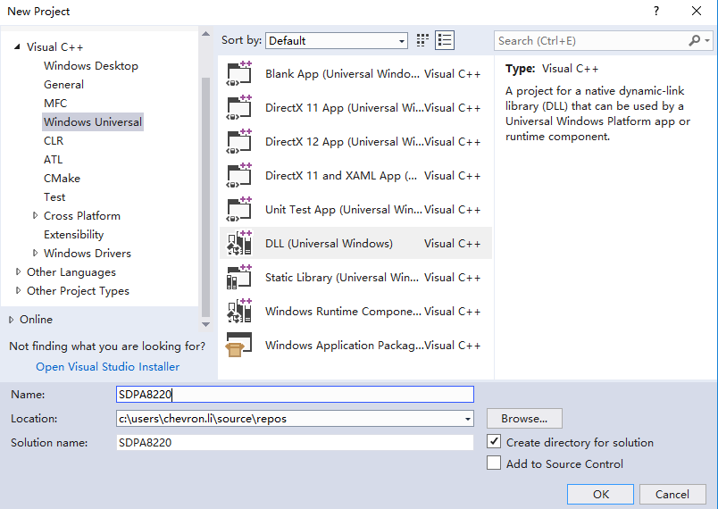

1. Add old project source code to the new project and declare the port functions with __declspec(dllexport) as follow in header file.

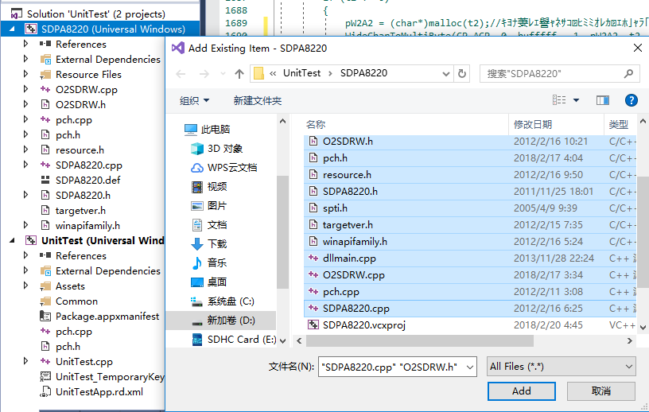

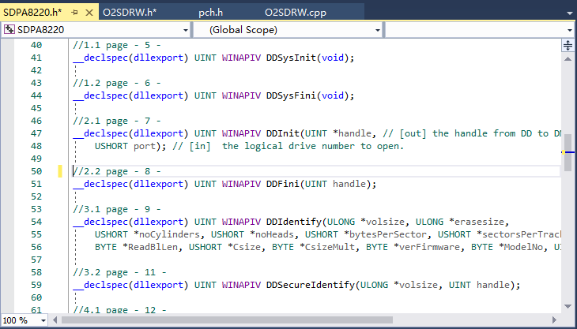

1. The preparation before build the project.
2. Change **Consume Windows Runtime Extension** with **Yes(/ZW)**

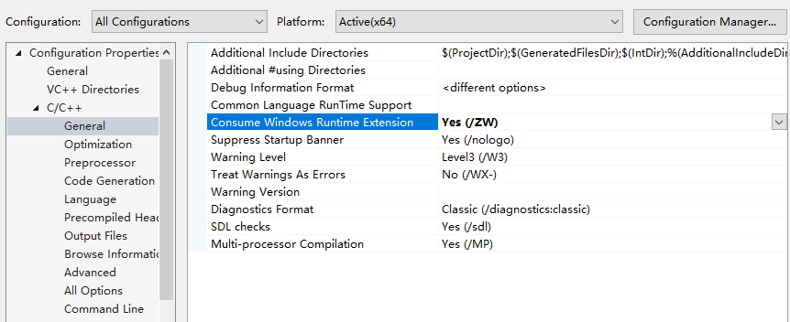

1. Add #define WINAPI_FAMILY WINAPI_FAMILY_DESKTOP_APP in header file or change properties as follow, because without this define many data structure can’t be used in Universal environment.

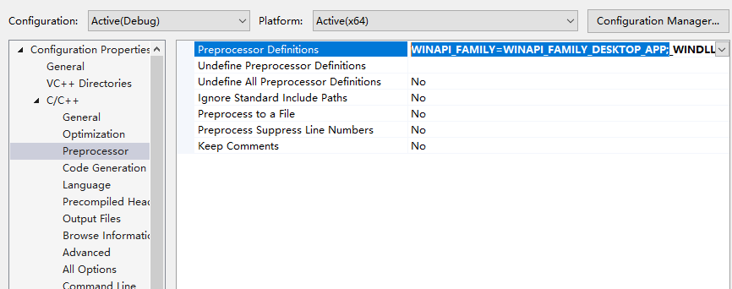

1. Build the project.
2. When build the project, some error may occur as follow in output.

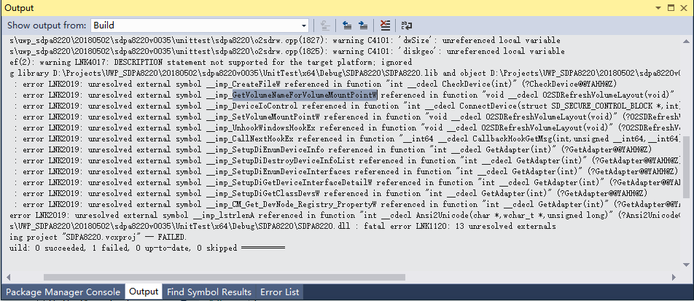

1. We need to search the functions which are unresolved external symbol on internet to find out their static library and add their static library at follow position.

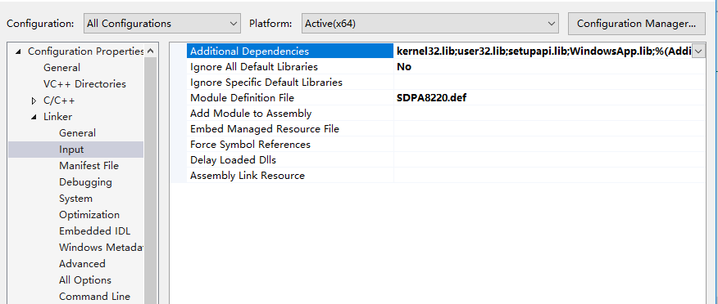

1. After solve above problem, rebuild the project again. Normally, it will be built successfully. If there are other errors, fixing it step by step.
2. debug
3. Create a new Unit Test project as follow to debug the Universal Dll project

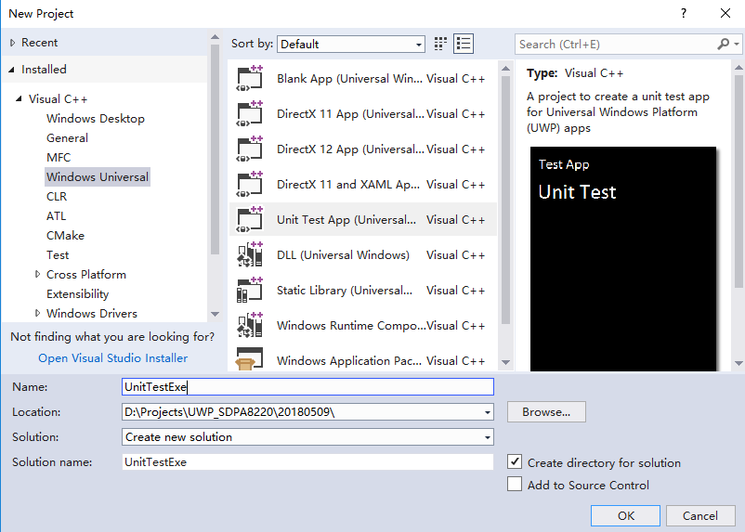

1. Add Dll project to the solution which include Unit Test project as follow.

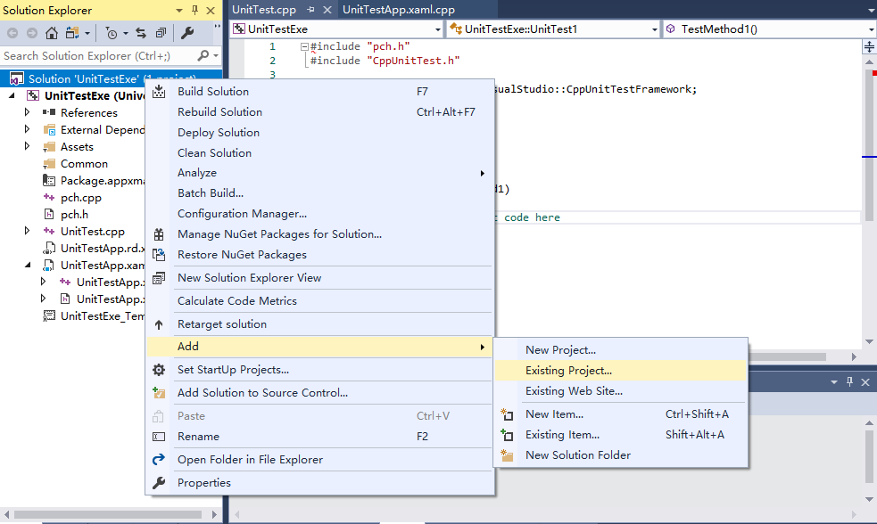

1. Reference Dll project in Unit Test project as follow.

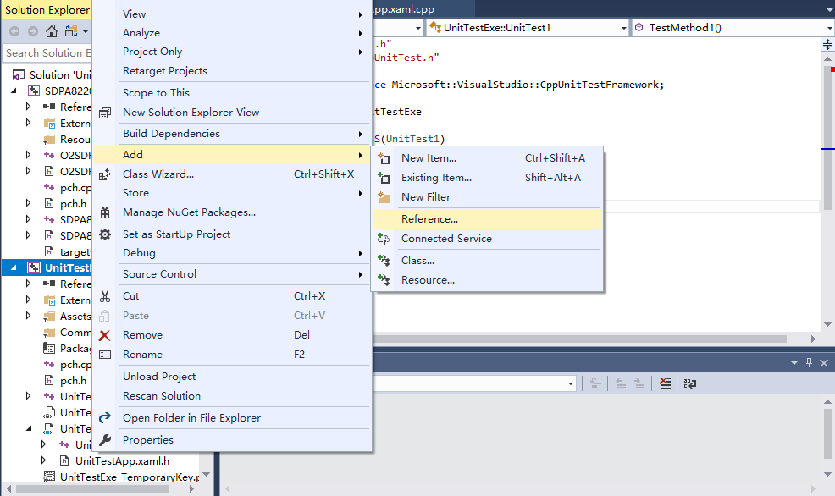

1. Add you code in UintTest.cpp
2. You must include the header file of port functions in it.
3. Add the function code which you want to debug.

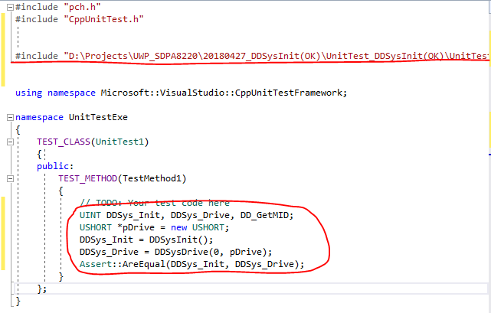

1. Set breakpoint and debugging output function in source code to debug it.

Find error and fix it.

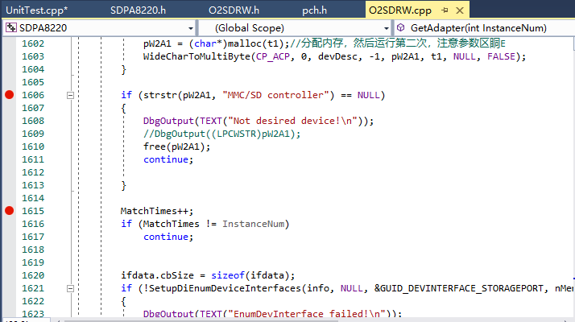

**The errors I encountered**

1. API doesn’t support universal environment. Error type: Conflict of Address

**Solution**: Search the API on <https://msdn.microsoft.com> to find a alternative

1. The path of driver can’t be identified. Error type: no warning just can’t get handle.

**Solution**: Transfer STR to Unicode.

1. Have no access to get handle. Error type: no warning just can’t get handle.

**Solution**: Create a .exe program to call the function in our dll.

1. Loadlibrary failed to get the address of .dll file. Error type: no warning just can’t get address.

**Solution**: Use Loadpackagedlibrary to load .dll file in universal project.